BRACT’s
Vishwakarma Institute of Technology, Pune
Practical Implementation Sheet
Department: CSE-AI Semester: 5 Academic Year: 2026-27
Division: E Batch: 1 Practical No: 2
Roll no: 64 PRN No: 12412320 Name of Student: Samyak Shende
Subject Name : Deep Learning

Problem Statement : Implement a Single-Layer Perceptron for binary classification and analyze the effect of weights, bias, and activation functions.

Algorithm :
- Start the program.
- Import the required TensorFlow and NumPy libraries.
- Define the input values and corresponding AND gate outputs.
- Create a Sequential model with one Dense neuron.
- Use the Sigmoid activation function.
- Compile the model using:
  - Optimizer: SGD
  - Loss Function: Binary Crossentropy
  - Metric: Accuracy
- Train the perceptron using the AND gate inputs and outputs.
- Predict the outputs for all input combinations.
- Display the learned weights and bias.
- Analyze the effect of weights, bias, and activation function.
- Stop the program.

Code :
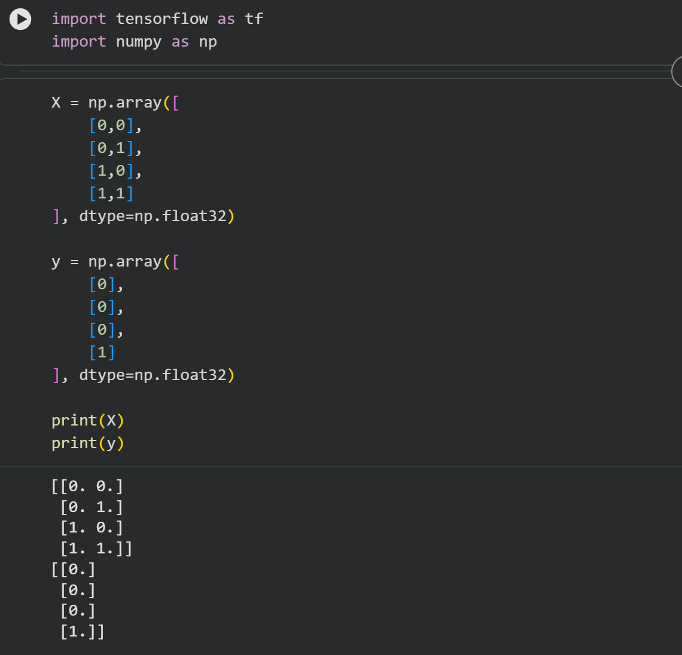
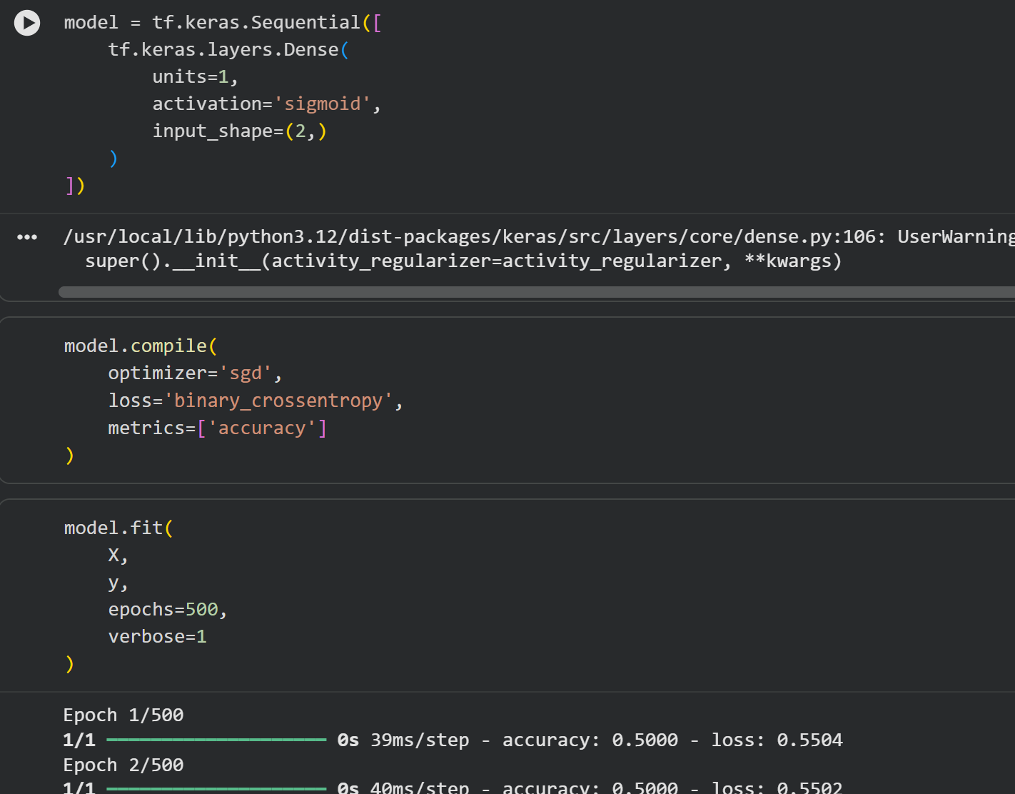
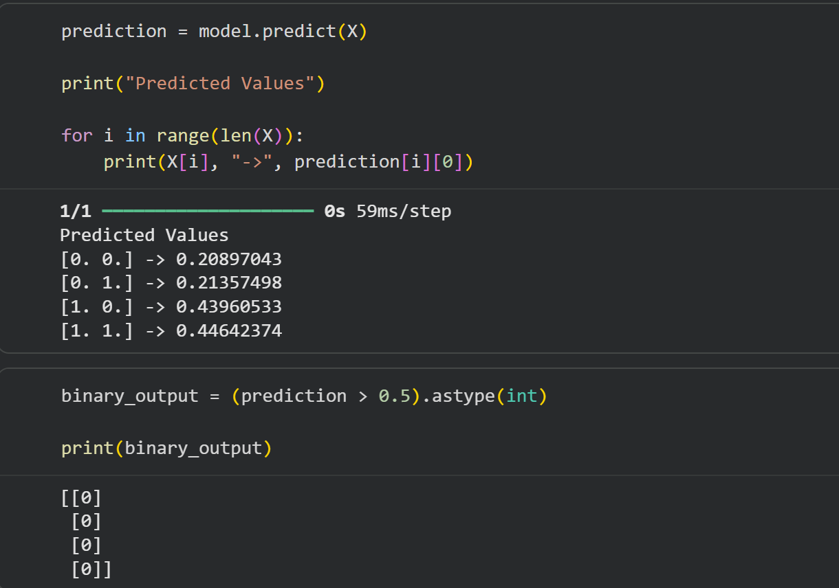

Output :
